50 Most Used Linux Commands
Suppose, you've started to use Linux recently, and you’re quite new to the command line interface. But one thing is certain: if you want to learn about some frequently used Linux commands and practice them on your own then you’ve found the right place. Here, we’ve discussed the 50 most used Linux commands with a brief description and practical examples.

List of 50 Most Used Linux Commands

sudo command
Sudo can be referred as the supreme command. It is the abbreviation for “Super User DO”. It allows a user to act as a superuser and run commands accordingly. One can run certain commands prefixed by sudo with boosted rights. It is considered analogous to the “run as administrator” process of Windows.

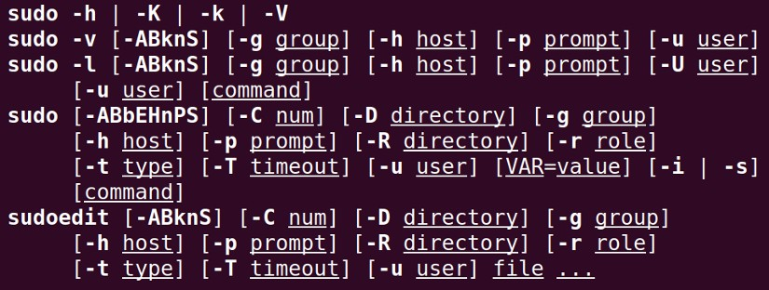
Synopsis

Useful Options
-D directory, --chdir=directory (executes the command in the specific directory)
-e (edits one or multiple files instead of executing commands)
-l (runs specific commands as the root user)
-u user, --user=user (executes the command as a user other than the specific default user)

Example
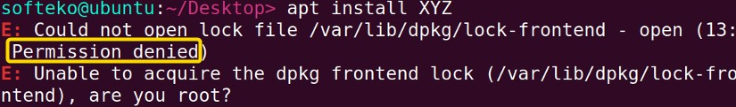

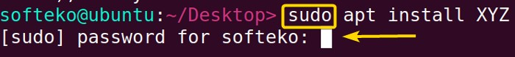
Any general user cannot install any packages on the machine. However, with sudo prefixed with the command, the user can execute his/her task by providing his/her password.

pwd command
Pwd is the abbreviation for Print Working Directory. As the name suggests, it prints the name of the current/working directory all the way beginning from the root(/) directory.

Synopsis

Useful Options
-L, --logical (Even as it carries symlinks, PWD utilizes from the environment. )
-P, --physical (avoid the symlinks)
When no option is mentioned, it is assumed that option -P is being used.

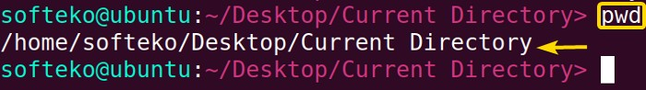
Example
Generally, Terminal prompts have a complete directory in the name. Otherwise, pwd becomes a handy command to get insights about the current working directory.

cd command
Change Directory(cd) allows one to change one’s current directory to the desired directory within the terminal.

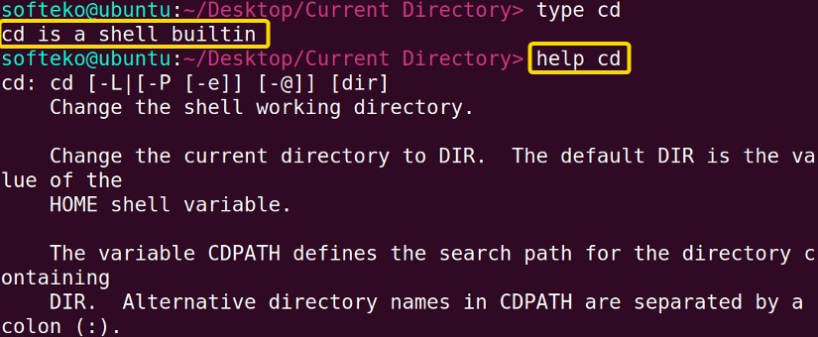
Synopsis
Note: cd is a shell built-in command, it doesn’t have a dedicated man(manual) page. However, you can get help using command help!

Useful Options
cd ~[username] — change the directory to the home directory of the specified user.
cd .. — changes directory one directory up the current directory.
cd - — changes the directory to the previously changed directory.

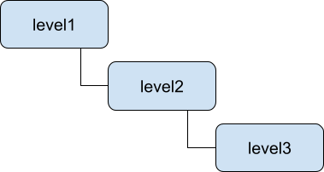
Example
In our Desktop directory, we have a 3-level nested directory. we want to leap forward to the level 3 directory by jumping one level at a time.
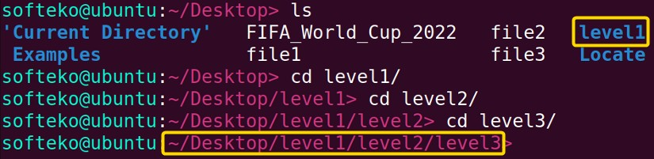

We have changed our mind, now we want to be at level2. Therefore, we just need to go one directory backward which can easily be done by executing the command cd ..

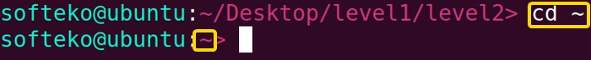
Lastly, we have come to the conclusion that we want to be in the home(~) directory. This can be simply done by executing cd ~ (tilde represents home directory).

ls command
Lists the contents, both files and subdirectories of the current directory by default. It is one of the most used commands, as one can view the contents of a directory without exiting the terminal and perform their desired tasks on the specific contents.

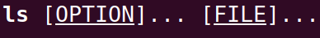
Synopsis

Useful Options
-a — doesn’t ignore the hidden files (files named with .(dot) at the beginning).
-h — print sizes in human-readable forms.
-l — lists in a long form.
-S — Sorts according to file size, largest first.

Example
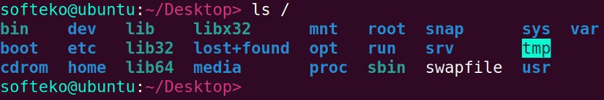
After being at the root(/) directory, if we run the ls command we can view the contents of the root directory.

cat command
Prints the contents of the file specified. Generally, cat (concatenates) reads the contents of the files fed to its arguments and prints them serially on the terminal.

Synopsis

Useful Options
-n, --number — Displays line numbers when utilized.

Example
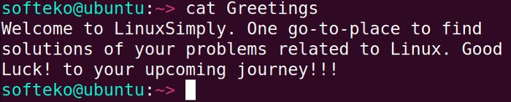
We can display the contents of a file simply by using the cat command followed by the file name.

mv command
Mv is the abbreviation for move. As the name suggests it moves things from one place to another place. mv moves one or multiple files to the specified destination directory. If the directory doesn’t exist it just renames the files. mv can also be used to move directories and their contents.

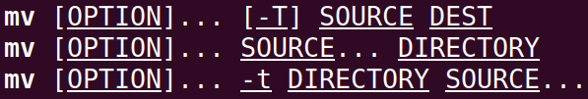
Synopsis

Useful Options
-i, --interactive (Displays interactive prompt before completing the modification)
-t, --target-directory=DIRECTORY (Moves every specified file to the targeted DIRECTORY)
-v, --verbose (Prints message of what is being performed.)

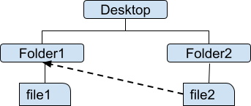
Example
In the desktop directory, there are two subirectories named Folder1 & Folder2 which respectively contains two files named file1 & file2. Now lets move file2 to folder1.

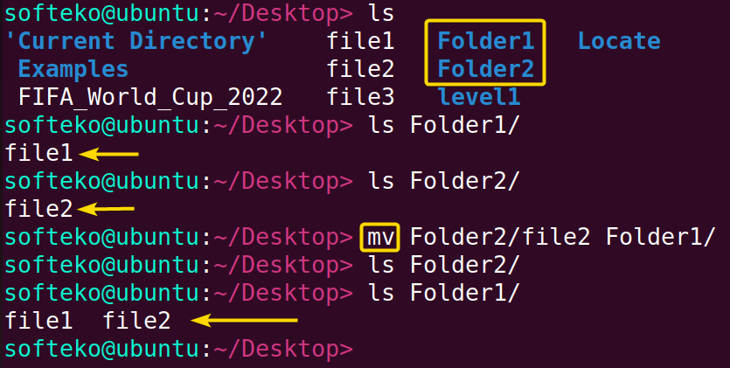

cp command
Cp is the abbreviation for copy. As the name suggests it copies things from one place to another place. cp copies one or multiple files to the specified destination directory. If the directory doesn’t exist it just renames the files. cp can also be used to copy directories and their contents.

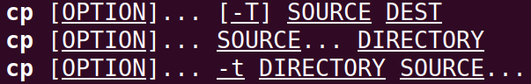
Synopsis

Useful Options
-i, --interactive (Displays interactive prompt before completing the modification)
-R, -r, --recursive (Copies the directories as well as its contents recursively)
-v, --verbose (Prints message of what is being performed.)

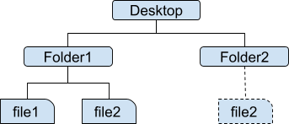
Example

In the desktop directory, there are two subdirectories named Folder1 & Folder2. In folder1 there is a file named file2. Let's make a copy of file2 in the Folder2 directory.
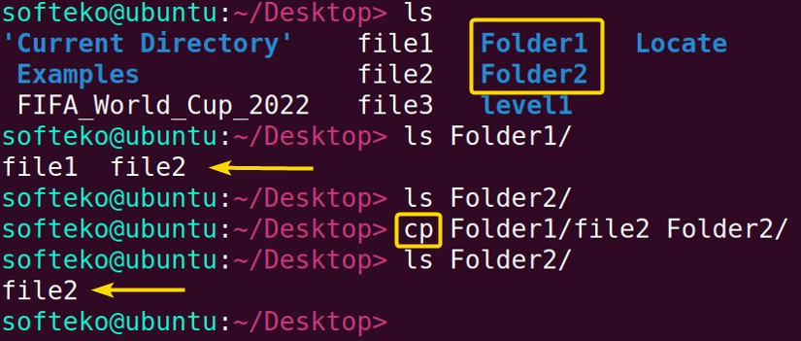

rm command
Rm is the abbreviation for remove. As the name suggests it removes things and the removal is permanent, so be cautious while using it. rm can also be used to remove directories and their contents permanently.

Synopsis

Useful Options
-i (Displays interactive prompt before completing the deletion each time)
-I (Less intuitive than -i, Only shows prompt while deleting 3 or more files or deleting recursively.)
-d, --dir (Removes the empty directories)
-R, -r, --recursive (Removes the directories as well as its contents recursively)
-v, --verbose (Prints message of what is being performed.)

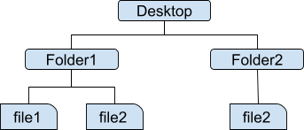
Example

In the desktop directory, there are two subdirectories named Folder1 & Folder2. Folder2 contains a file named file2. let's remove file2.
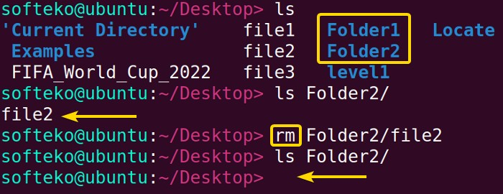

Now, Folder2 is empty let's remove this directory. To remove an empty directory option -d
has to be used.
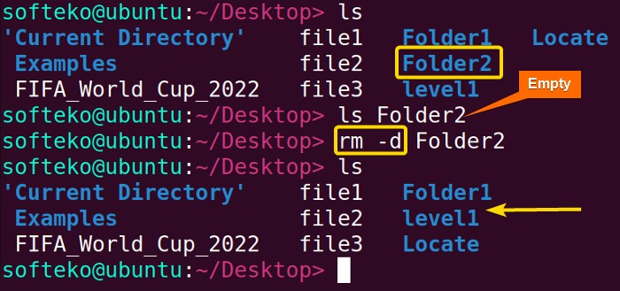

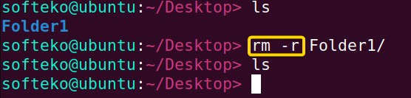
Finally, we have decided that Folder1 is also of no use to us. Let's remove this directory. However, it is not an empty directory so -d will not work. Instead, we have to use -r.

Disclaimer: You cannot retrieve anything after removing it through the rm command. So, better be careful with rm.

touch command
The touch command allows us to update a file's access or modification time. However, if the file doesn’t exist we can create that file. This ability to create files makes the touch command one of the most useful commands.

Synopsis

Useful Options
-a (changes only the access time)
-m (changes only the modification time)

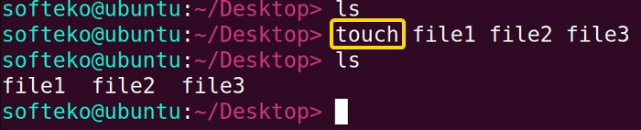
Example
We created 3 files in our current directory, Desktop named file1, file2 and file3 with the help of the touch command.

mkdir command
mkdir is the abbreviation for make directory. As the name suggests the mkdir command can be used to create one or more directories.

Synopsis

Useful Options
-p - -parents (Creates the necessary parent directories if required)
-v, --verbose (Prints message of what is being performed.)

Example
Let’s make a directory named ‘Examples’ in our desktop directory which will contain one subdirectory named ‘NoExamples’.

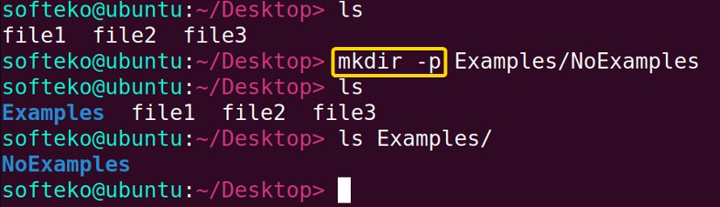

Note: Option -p is used to create the necessary parent directory, in this case, which is ‘Examples’.

locate command
The locate command performs the search operation from an existing database and prints the results with the exact directory path.

Synopsis

Useful Options
-c (Does not print any matches rather total occurring number)
-e (Only prints the existing match)
-i (Ignores the sensitivity of cases)

Example
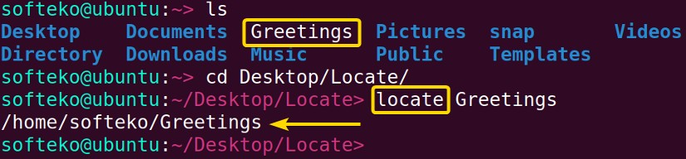
We have a file named Greetings in our ‘/home’ directory. After changing our current directory from ‘/home’ to ‘/Desktop/Locate’ we operated the locate command.

find command
The find command searches in real-time not like the locate command from an existing file.

Synopsis

Useful Options
-type d/f (d(limits the search to only directories), f(limits the search to only files)).
-size +n,n,-n (Finds for a specific size n.)
-name pattern (Will search for the given pattern)
-exec (can be used to perform our customized tasks on the matches.)

Example
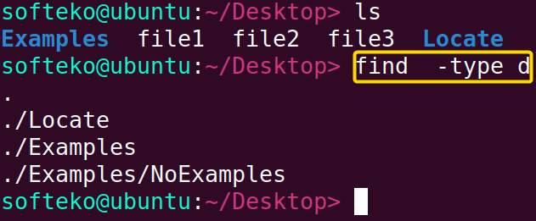
We will only limit the find operation to directory type.

grep command
The grep command can be used to search patterns in specific files or each file. Then prints the entire line containing the match.

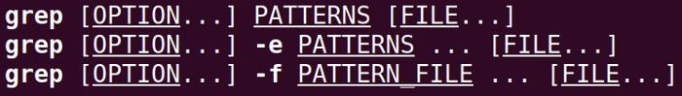
Synopsis

Useful Options
-c (Does not print any matches rather total occurring number)
-i (Ignores the sensitivity of cases)
-w (search for a whole word)

Example
We have a text file named “FIFA_World_Cup_2022” in our desktop directory. Let’s search for ‘FIFA’ in the file.

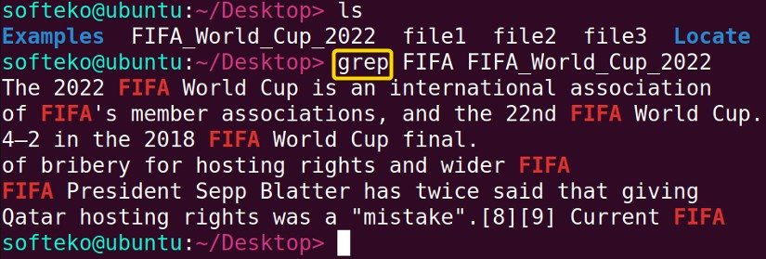

Now, if we want to just know about the occurrence number, we have to use the -c option.

head command
The head command prints the first(by default 10 lines) few lines of a file.

Synopsis

Useful Options
-n (Prints the first n lines.)
-v, --verbose (Prints message of what is being performed.)

Example
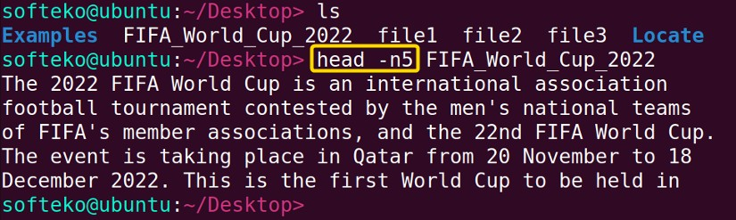
We want to print the first 5 lines of the “FIFA_World_Cup_2022” text file. It can be simply done using the head command with -n5 option

tail command
The tail command prints the last(by default 10 lines) few lines of a file.

Synopsis

Useful Options
-n (Prints the last n lines.)
-v, --verbose (Prints message of what is being performed.)

Example
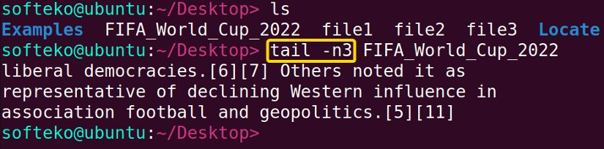
We want to print the first 5 lines of the “FIFA_World_Cup_2022” text file. It can be simply done using the tail command with -n3 option

man command
You are whether a beginner or a professional Linux CLI(command line interface) user, the command you will interact with for the most is certainly the man command. The man command enables the user to learn more about a specific command i.e. syntax, options and arguments of that command.

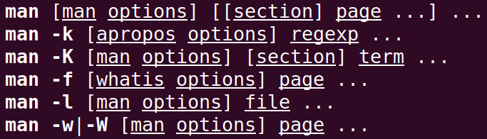
Synopsis

Useful Options & Shortcuts
-k, --apropos (Displays the short manual page on the terminal)
-I, --match-case (Performs case sensitive manual page search)
/pattern (It is a useful search shortcut built-in inside the man page.)

Example
You can navigate through the man page using arrow keys and other specific keys. To know more about the man page navigation try pressing h on the man page of any command.

$ softeko@ubuntu:~/Desktop> man man

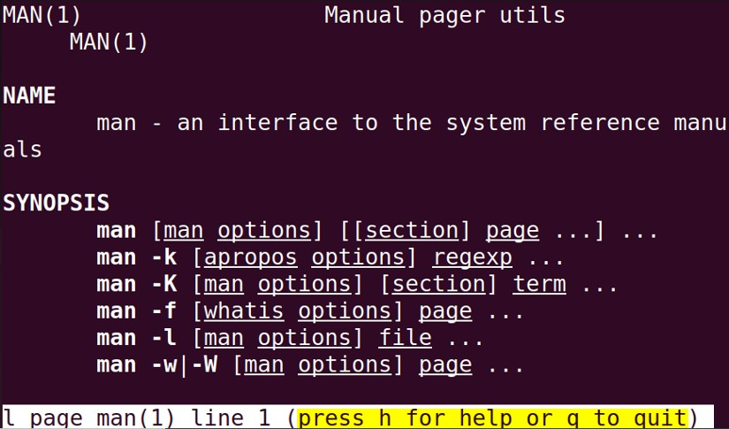

You can print short information from the man page using option -k.
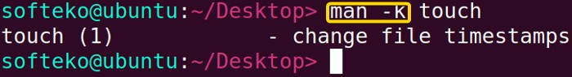

history command
Executing this command one can view the previously used commands in the terminal.

Synopsis

Example
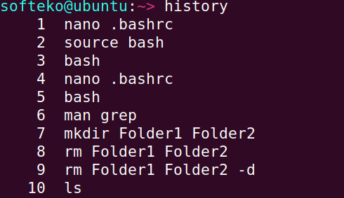
let’s view some of our previously executed commands using the history command.

chmod command
chmod is the abbreviation for change mode. The chmod command can be used to alter the permission attributes of system contents.

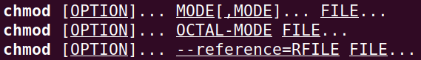
Synopsis

Useful Options
u represents user (u+x will empowers user with executable permission.)
g represents groups (g-w will revoked the modification power of members of the group.)
o represents others (o+r will empower others to read the contents.)
a represents all (a=r will grant everyone accessing power however it will revoke everyone from write and execution permissions.)
-c, --change (reports the occurrence of change.)

Example
The modification permission represented by character w of groups for filem named “file.txt” can be revoked using the command chmod g-w.

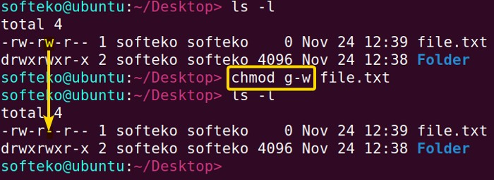

Now, for the directory named “Folder”, we want that everyone only be able to read the file. This canbe simply be done by using the command chmod a=r.
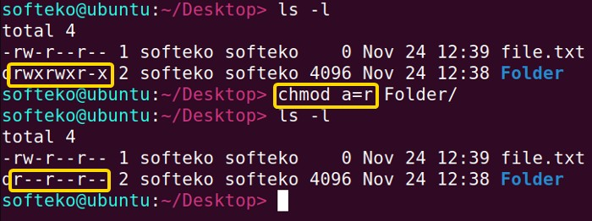

chown command
The chown (change owner) command can be used to alter the owner of system files & directories.

Synopsis

Useful Options
-c, --change (reports the occurrence of the change.)
-R, --recursive (operates recursivelyon the desired files & directories)

Example
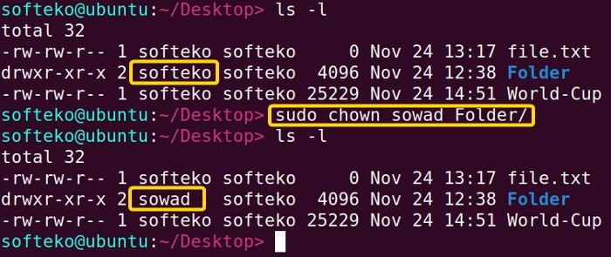
We want to change the ownership of a directory named “Folder”. It can be easily done using the chown command. However, we need to use sudo as a prefix of chown as only the root user has the permission to do so.

echo command
The echo common is one of the simplest commands, it prints whatever we give to it.

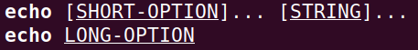
Synopsis

Example
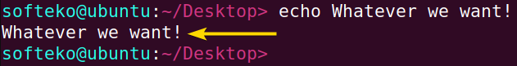
Let's print whatever we want!!!.

Let's print today’s date. However, if we feed ‘date’ to echo it will just literally print ‘date’ so we have to use special syntax $(command).
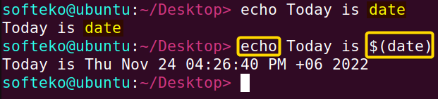

alias command
The alias command can be used to replace a command with user-modified instructions while running the command.

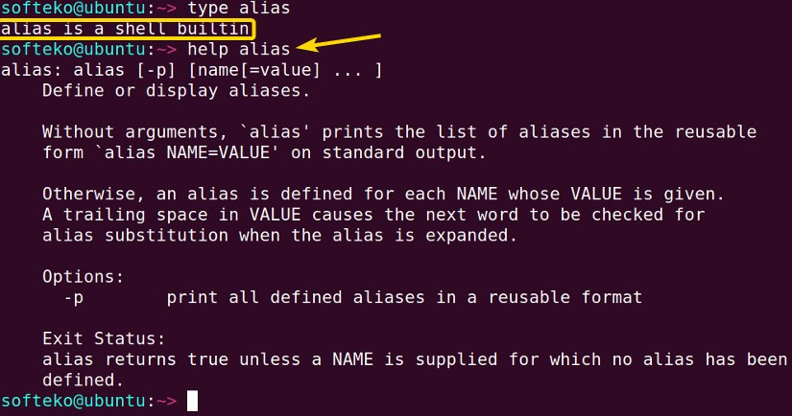
Synopsis
Note: Shell builtin commands don't have man pages. The help command can be used here.

Example
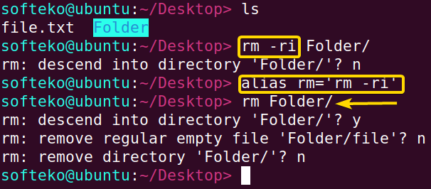
If we want to remove directories/files with the rm command while adding a confirmation prompt we need to run rm -ri. Now, we can make just rm sufficient enough to do the task of rm -ri, using the alias command.

passwd command
The passwd command can be used to change the password of a specific user.

Synopsis

Useful Options
-d --delete User’s password can be deleted.
-e --expire Immediately makes the password expired.
-i --inactive INACTIVE makes the password inactivate after a specific INACTIVATE period.

Example
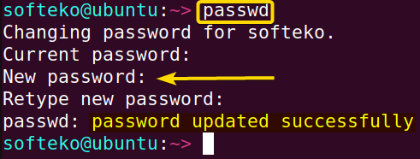
We can simply change our password for the current user with passwd command.

less command
The less command is used to display the contents of a file on the terminal screen in page by page manner.

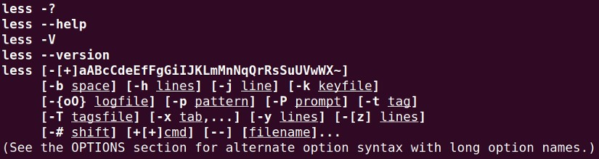
Synopsis

Useful Options
-n --line-numbers (when enabled it stops showing line numbers)
-N --LINE-NUMBERS (displays line numbers at starting points of each line.)

Example
We want to view the file named “World_Cup” with line numbers. This can be done by using the less -N command.
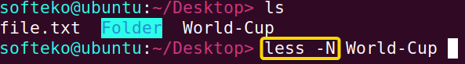

Arrow keys can be used to navigate through the less view.
Press q to exit the less display.

whoami command
The whoami command simply displays the currently logged-in user.

Synopsis
Example
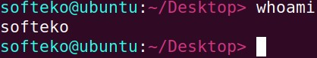
The whomai command displays the current user in our case which is softeko.

kill command

Synopsis

Example

The top command can be referred to as the task manager of linux. It shows information regarding CPU and memory optimization.
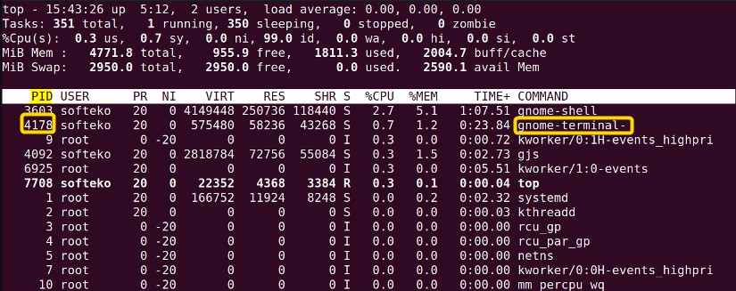
The process ID(PID) of the terminal is 4178 in this case. Now using the kill command with the PID of the terminal as its argument we can close the terminal.

zip Command
zip command is used to compress files or folders into a .zip file in UNIX and UNIX-like operating systems. This allows for reducing the size of files and disk usage. Converting many files, and folders into a .zip file allows sharing and maintaining disk location by reducing file zie without any loss.

Synopsis

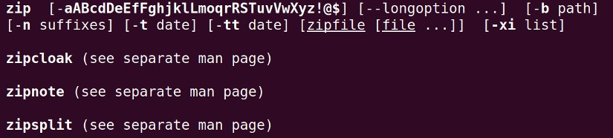

Useful Options
-e, --encrypt (encrypt a file with a password which is entered through the prompt)
-i \*.txt (include the only files with some conditions)
-m (moves the files into the zip files, deletes the original files after compression)
-r, --recurse-paths (compression throughout all the files and folders recursively)
-s, --split-size SIZE (the zip file is split into many different files into a specific size)

Example
We can use zip command to compress a single file.

We can also compress multiple files.

We can encrypt a file with password with -e option.

We can move the file into a .zip file and delete the original with -m option.

unzip Command
unzip command is used to extract files from a .zip file. This command creates a new folder in the current directory where the field inside the zip files is extracted.

Synopsis

Useful Options
-u (update existing files inside the folder and create new ones if required)

-i (shows the files or folders inside the compressed document)

Example
To simply extract files from a compressed folder, we use unzip command.

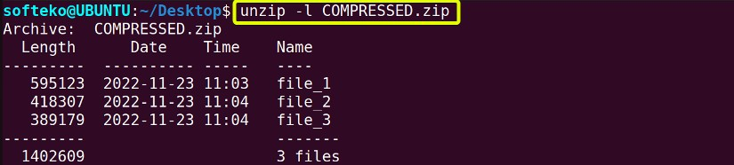
We can use -l option too view the files inside the compressed files.

wget Command
wget is a download command which downloads files or webpages non-interactively from the network.

Synopsis

Useful Options
-b (downloads a file in the background)
-c (continues a partially downloaded file)

Example
To download a webpage, we can use wget command.

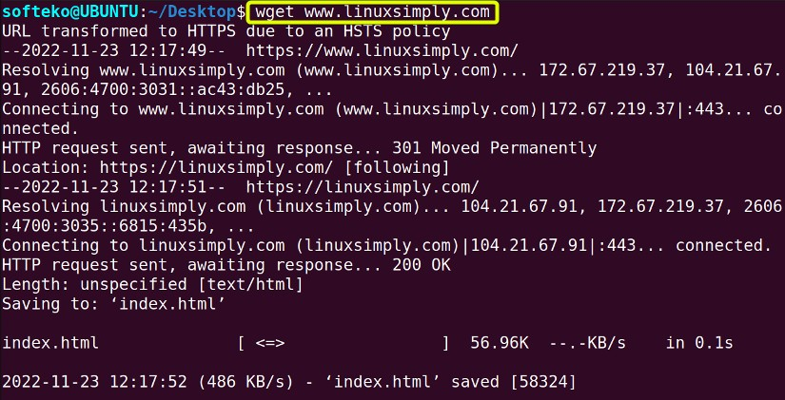
To download a webpage in the background requires -b option.

df command
df (disk free) command shows the size, used, available space and mounted on the information of the filesystem.

Synopsis

Useful Options
-a, --all (displays all file systems including inaccessible or hidden files)
-h, --human-readable (displays information in human-readable format)
-t, --type=file_type (displays files of a certain file type)
-l, --local (displays local file system)

Example
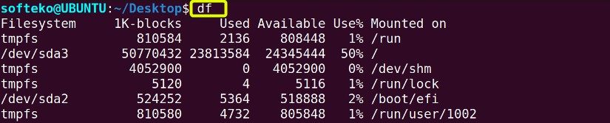
Using only df command shows default information.

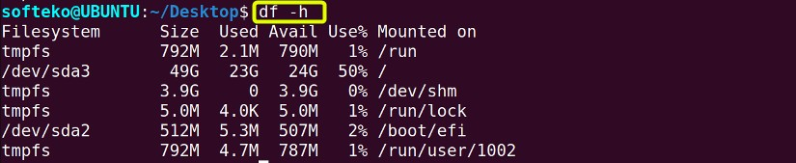
Using df -h shows us the file size in a human-readable format.

Using df file_name shows information about only the file_name.

ping command
ping (Packet Internet Groper) command shows the information about the network information about the host and the server. It can check the internet connection and show the latency between the host and server.

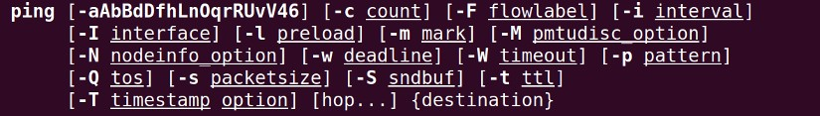
Synopsis

Useful Options
-c COUNT (sends COUNT number of ECHO_REQUEST)
-i COUNT (sends a packet in every COUNT second interval)
-f (flood ping with rapid display, sudo permission is needed)

Example
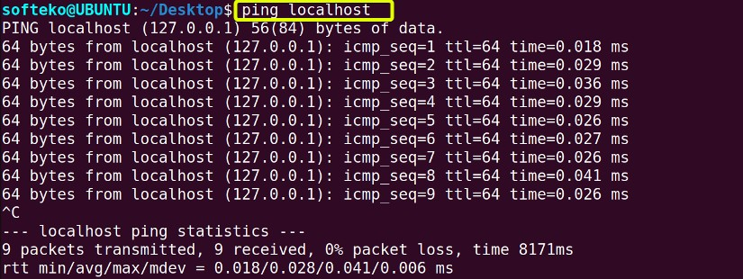
Finds information about the localhost, exiting the command needed, using ctrl+c.

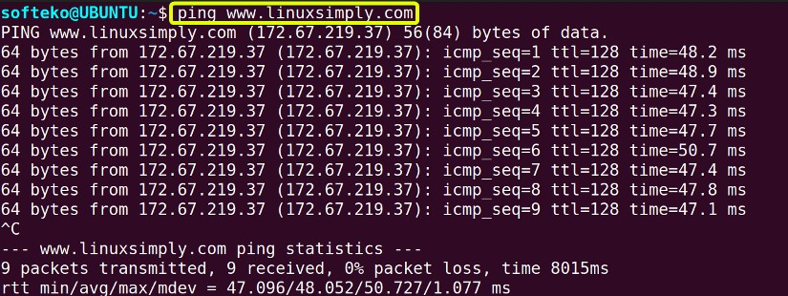
Finds ping information about a website exiting the command needed, using ctrl+c.

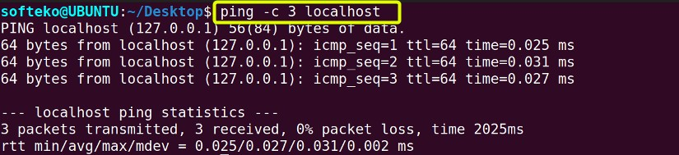
We can add -c NUM option to limit the number of packets using ping.

diff command
diff command finds checks 2 files and shows the difference between 2 files. Normally, it does not change the content of files, but it can generate a script.

Synopsis

Useful Options
-c (shows the differences between the 2 files in context mode)
-u, -U, --unified (shows the unified context of the 2 files)
-r, --recursive (compares files inside any subdirectories)
-i, --ignore-case (ignore cases)

Example

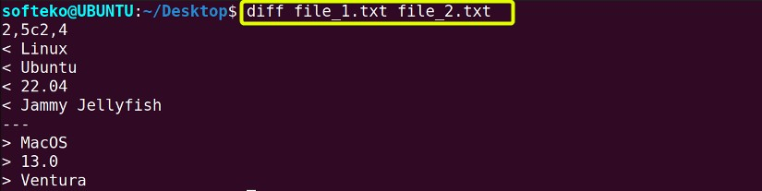
Using the diff command with 2 files shows the difference between those 2 files.

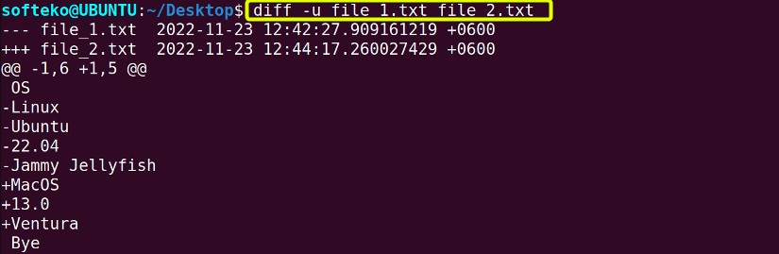
We can use -u option to see the difference in the unified context of 2 files.

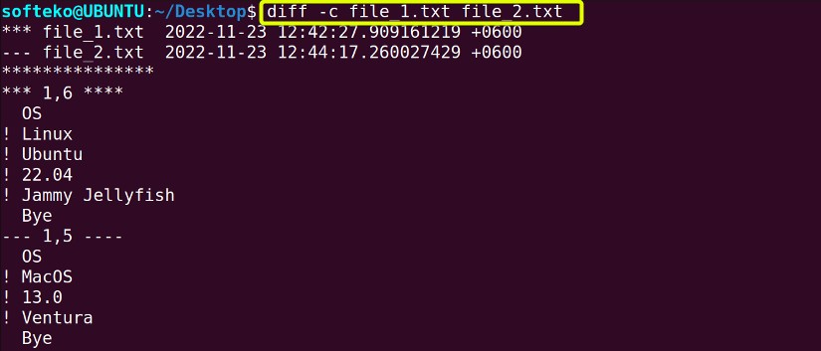
Option -c shows both files in context mode.

ps command
ps (Process Status) command shows the process status and information about that process.

Synopsis

Useful Options
-a, --all (shows all the processes including hidden processes)
-r (shows all the running processes)
--pid PID (shows the specific process according to PID)

Example
Simply typing ps shows the process status of the Linux system.

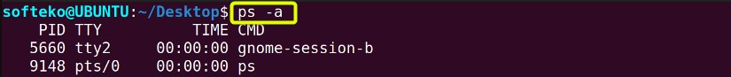
Option -a shows all the processes including hidden processes.

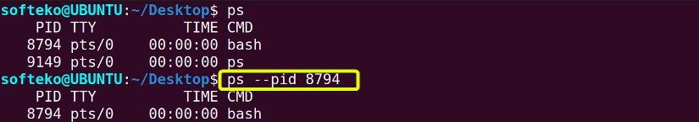
To look into a specific process, --pid command is used.

apt command
apt (Advanced Package Tool) command manages different packages including install, remove, update, etc.

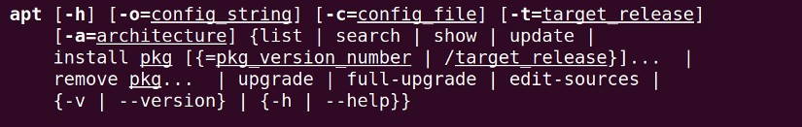
Synopsis

Useful Options
apt [install, update, upgrade] (downloads package information and install, update or upgrade the package, sudo permission is required)
apt full-upgrade ( upgrade all installed packages, even remove some if required)
apt remove Package_Name (removes a specific package)
apt autoremove (removes unneeded dependencies)
apt --only-upgrade install Package_Name (installs or upgrades a specific package)

Example
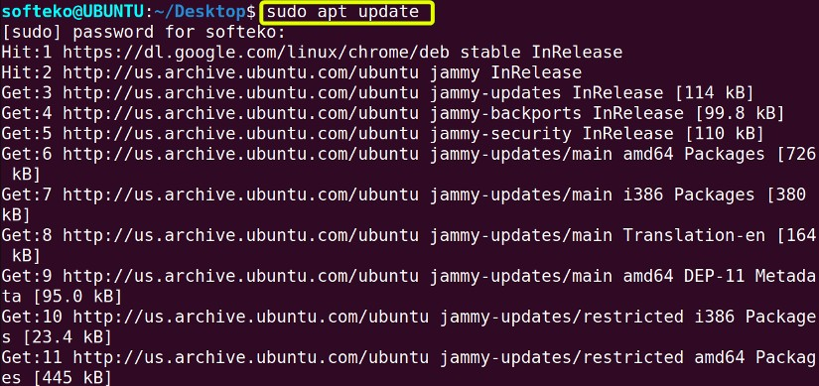
sudo apt update command updates all packages.

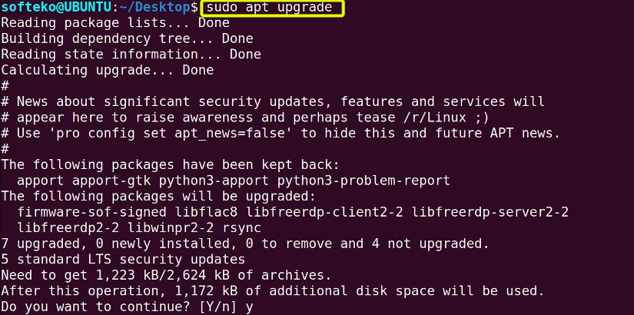
We can use sudo apt upgrade command to upgrade all available packages.

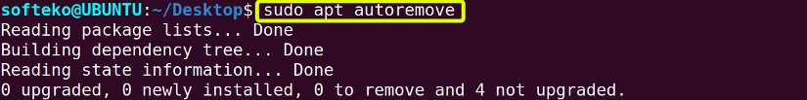
The autoremove option removes all unneeded dependencies.

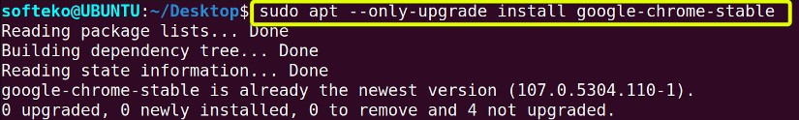
The --only-upgrade Packae_name option updates a specific package.

dd command
dd command converts and copies a file to another directory. This command can be used to create a backup inside the hard drive or an external hard drive.

Synopsis

Useful Options
if (read the file instead of standard input)
of (write the file instead of standard output)

Example
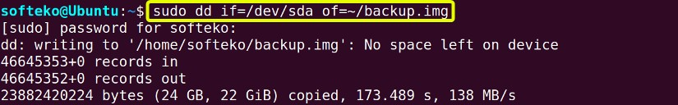
dd command is used to back up a folder into another directory as backup.img file.

top command
top (Table Of Processes) command shows the currently running process inside linux. It gives a dynamic but not interactive view of the process.

Synopsis

Useful Options
-n NUM (shows the top NUM number of processes)

-u PARAS (shows the processes according to PID or User as given as paras)
-d TIME (shows a dynamic view which updates in TIME tenth of seconds)

Example
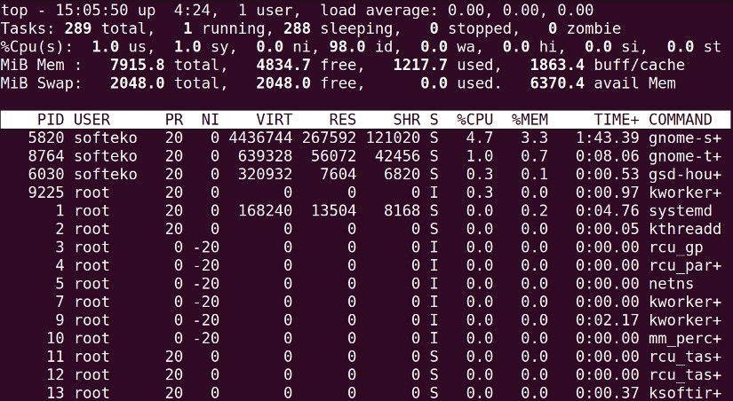
Simply typing top shows the processes dynamically.

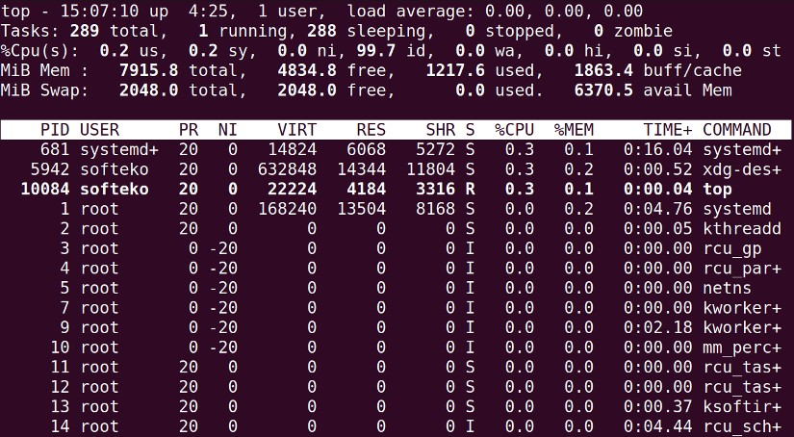
We can use option -n 10 to find the top 10 running processes according to cpu usage.

htop command
htop process is quite similar to the top process but in htop, the user can have interactive control over the top running processes in Linux. htop may need to be installed in the terminal first for usage.

Synopsis
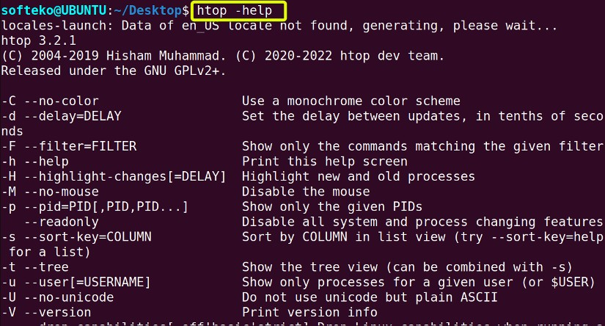
There is no manual page for htop, but help, there are different commands and options shown.

Example
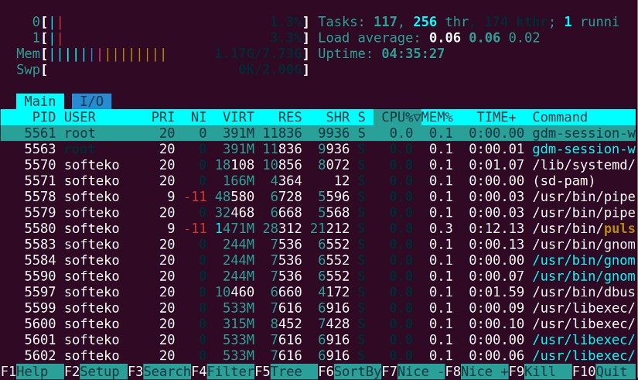
Simply typing htop shows the prompt where each process can be analyzed interactively.

useradd command
useradd command is used to add a user to the Linux system. sudo command is needed to create a new user. The superuser sudo command is required to use this command.

Synopsis

Useful Options
-d DIRECTORY USER_NAME (creates a user in DIRECTORY)
-u, --uid ID (creates a user with the user id of ID)
-g --gid ID (creates a user with a group id of ID)
-M USER (creates a user without any home directory)
-e DATE USER (creates a user with an expiry date)

Example
Creating a simple user is possible with useradd command.

Option -d creates a user inside a specific directory.

We can also use -u NUM to create a user with a specific user id.

unalias command
unalias command removes alias created before.

Useful Options
-a (removes all alias)

Example

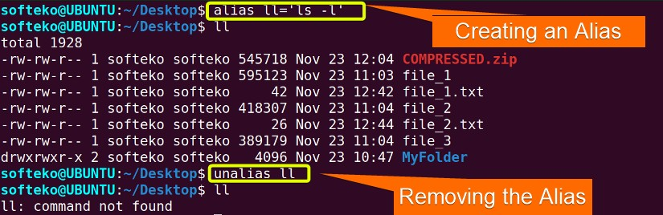
Removes an alias can be done using unalias ALS command.

Removing all alias requires using -a option.

uname command
uname command shows information about the system. Without any option it prints Linux.

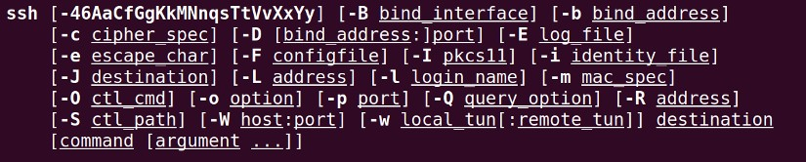
Synopsis

Useful Options
-a (displays all information about the system)
-o (displays the operating system name)
-s (displays the kernel name)
-p (displays the processor type)

Example
Option -s displays kernel name.

Option -o displays operating system name.

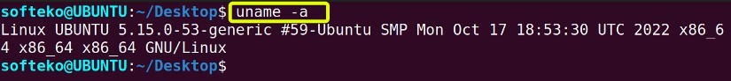
We can use -a to display all information about the system.

ssh command
ssh (Secured Shell) command is used for securely connecting to a remote server.

Synopsis

traceroute command
traceroute command displays the packet route to reach the host. This command can be used to see the different hops or routes it takes to connect with a particular hostname.

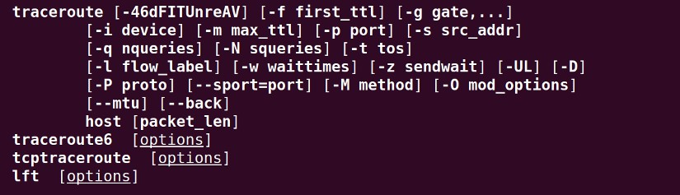
Synopsis

Useful Options
-g Host_name (Routing the packet through a gate or IP address)
-m Host_name (Fixing the maximum number of packets)

Example

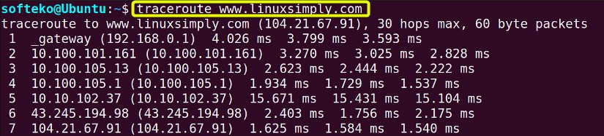
Simply typing traceroute shows the maximum number of hops and the routes.

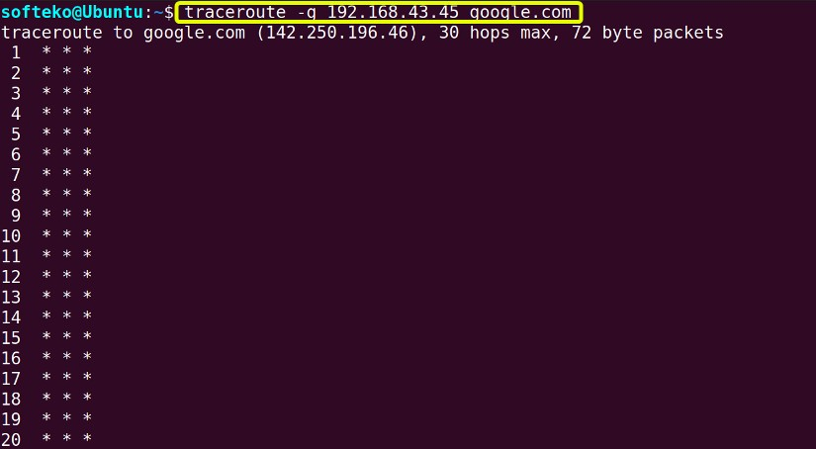
To fix a gate for routing -g option is used.

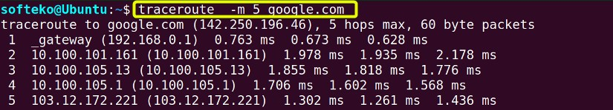
To fix the maximum number of hops, -m option is used.

groups command
Groups are used to manage multiple users and permissions. Several users can be members of a group and then the group can have permission for some files or folders to manage permissions.

Synopsis

Example

Simply typing groups will display all the available groups in the machine.

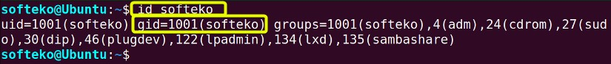
We can use id command to find the group's id.

shutdown command
shutdown command is used to shut down the system with some conditions. This command can schedule a shutdown at a specific time or cancel an already scheduled shutdown. The superuser sudo permission is required for this command.

Synopsis

Useful Options
--halt Time/Delay (Schedule a shutdown at a specific time or after a certain delay)
-c (Cancel any shutdown command scheduled beforehand)
-r Time/Delay (Schedule a restart at a specific time or after a certain delay)

Example
Option --halt can schedule a shutdown at 2:00 PM. The display will also show the date and the region.

We can also schedule a shutdown after a 5 minute delay --halt option.

Option -c cancels a shutdown.

exit command
exit command exits the terminal. It is a shell command, which means it doesn’t have any man page.

Synopsis

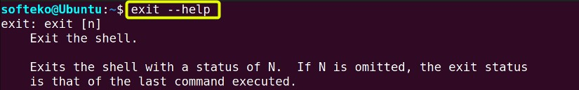

Example
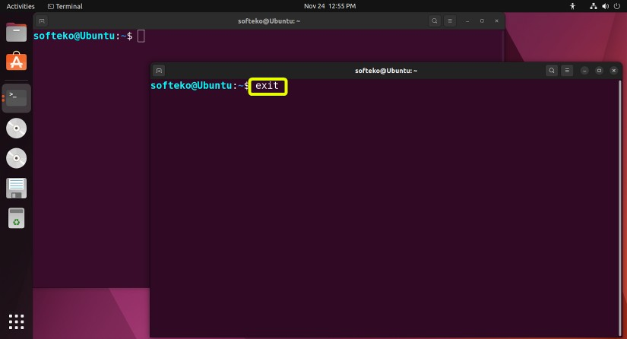
exit command terminates or exits a terminal.
Now that terminal is not available anymore.
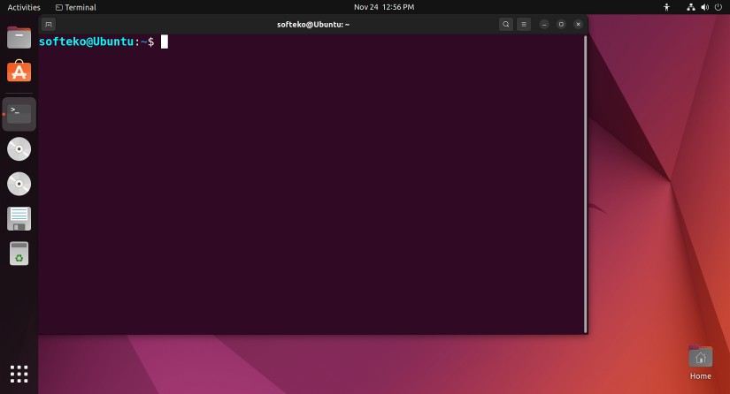

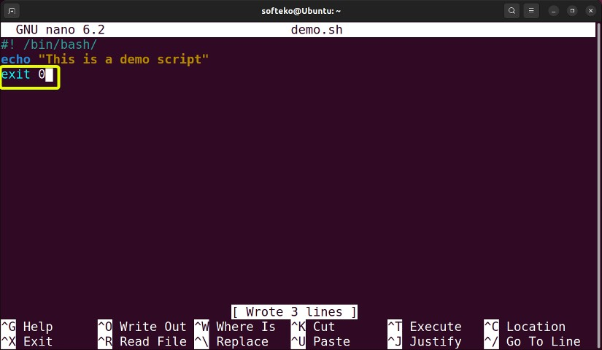
The command exit is also used to exit a script. First, a demo script is created and exit 0 is present at the end.
Now running the script using bash command, the script will exit at the end.
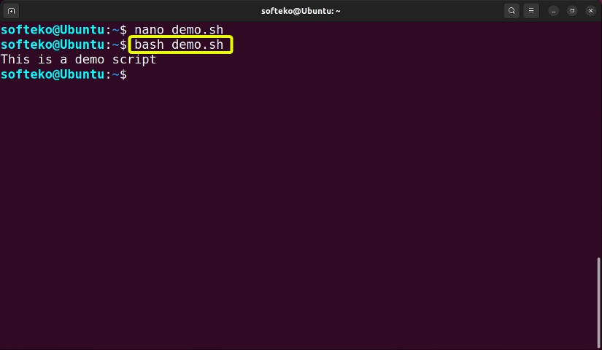

wc command
wc (Word count) command is used to count the number of characters or the number of lines in a file.

Synopsis

Useful Options
-l File.txt (shows the number of lines)
-w File.txt (shows the number of words)
-c File.txt (shows the number of characters)

Example
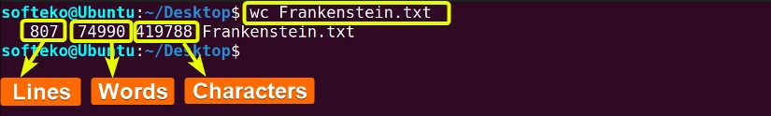
Simply typing wc Filename.txt shows the line, word, and character count of the file.

Using -l option shows the number of lines of that file.
Using -w option shows the number of words in that file.

Using -c options shows the number of characters in the file.

sort command
sort command sorts the content inside a file and shows it in the display. By default sort
command sort alphabetically. But different conditions can be applied for flexibility.

Synopsis

Useful Options
-o Main_file Sorted_File (sort and create a new sorted file)
-r, --reverse File (sort in reverse order for a specific line, sort in horizontal order)
-n, --numeric-sort File (sort in numeric order)
-kNUM (sort by using a key NUM, sorting by NUM column is possible using this option)

Example

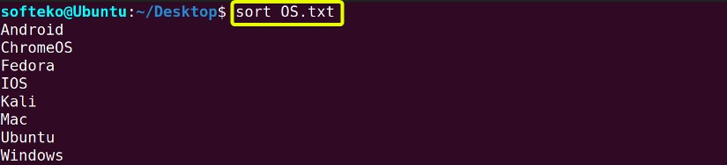
Simply typing this command sorts the contents inside a file alphabetically.
Sorts the content inside a file and creates a new sorted file.
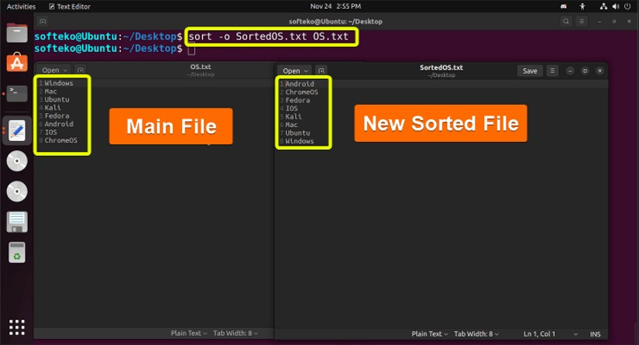

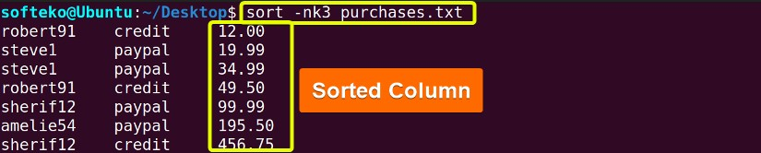
-nk3 option sorts the using the third column numerically.

cal command
cal command stands for the calendar. It shows calendars in many different formats according to the condition.

Synopsis

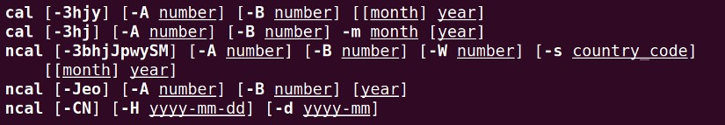

Useful Options
-y (shows the whole calendar of the current year)
cal MM YYYY (shows the calendar of the MM month of YYYY year)
cal YYYY (shows the calendar of the YYYY year)
-j (shows the Julian calendar)

Example
Simply typing cal shows the current month calendar.

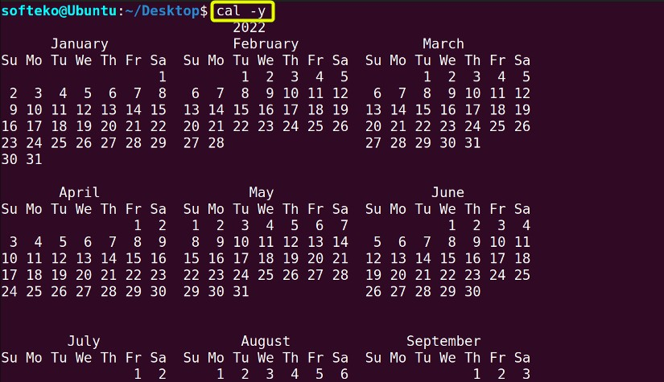
Using -y option shows the whole year calendar.

Typing the month MM and year YYYY shows the calender of that specific month.

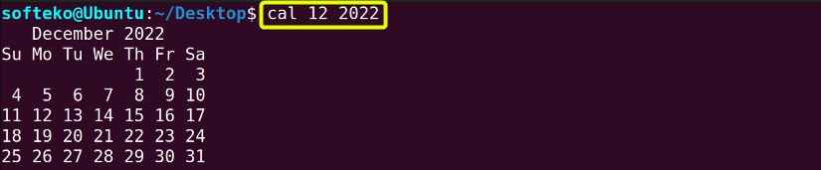

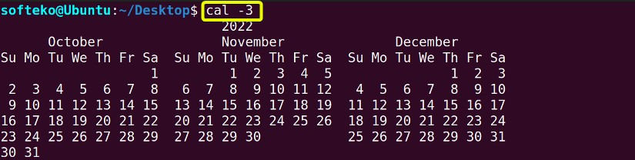
Using -3 command shows the calendar of the current, previous and next month.

nano command
Nano is another text editor. It is a simple and intuitive text editor that has many different shortcuts and is very light. It comes with the basic Ubuntu install.

Synopsis

Example
Just typing nano Filename.txt starts the nano text editor.

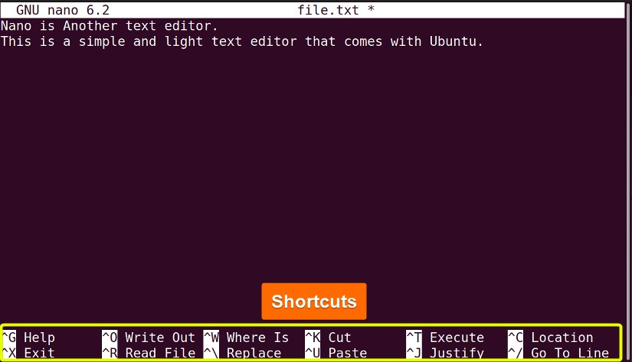
Many shortcuts of nano are available at the bottom of the terminal.

du command
du command means disk usage. Using this command the total usage of the disk and the disk usage of the different files are shown in the terminal.

Synopsis

Useful Options
-a (shows the total disk usge)
-ah (shows all files disk usage)
--time (shows the last modification time)

Example
Just typing du displays the disk usage of the current directory.

-a option can be used to find disk usage of individual files inside the current directory.

-ah command is used to show all individual files’ disk usage in a human-readable format.

We can use --time option to show the last modification of the directory.

apt-get command
apt-get command is quite similar to the apt command. But in apt-get common is generally used in the back-end and has backward compatibility. The apt-get (Advanced Packaging Tool) command is used for retrieving package and managing (install, upgrade, update, remove) the package.

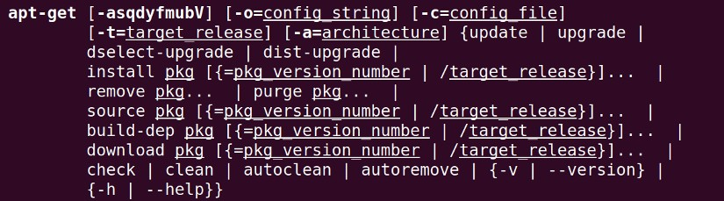
Synopsis

Useful Options
apt-get [install, update, upgrade, remove] (retrieve the package and install, update, upgrade or remove the package from the system)
--download-only (downloads a package without installing or updating)
--autoremove, --auto-remove (removes unnecessary packages from the system)
--version (shows the version)

Example
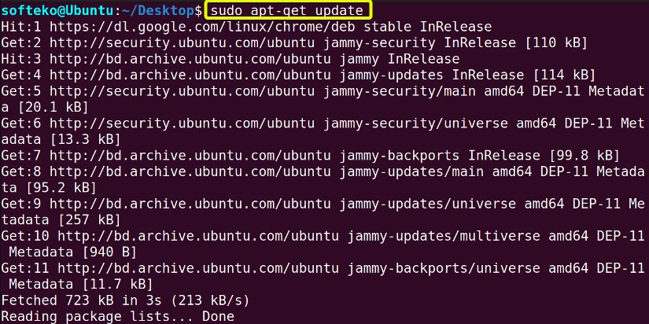
update command is used to update packages in the system.

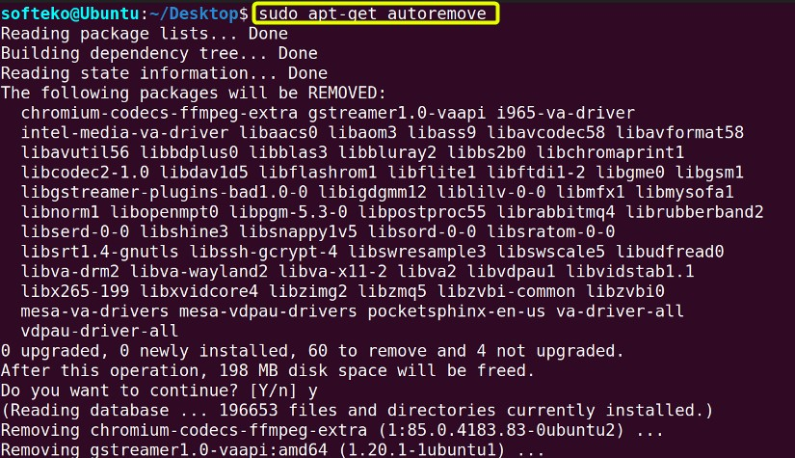
We can use autoremove option to remove unnecessary packages that are not being used.

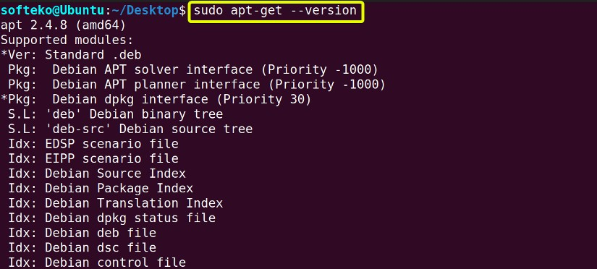
Option --version shows the version of the apt-get. It also shows the other possible commands on which --version command can be used

Conclusion
In this article, we covered the 50 most used Linux commands that a regular user will encounter most of the time. Of course, there are many more of these commands and each of these commands has many more options and functionality available for the user.
You don’t need to memorize every one of them and we already have a free pdf document available that covers all these commands.
We will shortly cover every one of these commands individually and go into the details. In the meantime, you can also bookmark this page in case you need to have a look at any of these commands.

